<Project NAME>

To put in a client name select all (ctrl A) then f9Nash Tech Software Development

**Detailed Design**

**Version 1.0**

**7thMay, 2010**

13 Bruton Street

London

W1J 6QA

Tel: +44 (0)20 7333 0033

Fax: +44 (0)20 7333 0032

Email: [Tim.lewis@harveynash.com](mailto:Tim.lewis@harveynash.com)

DOCUMENT HISTORY

|  |  |  |  |  |
| --- | --- | --- | --- | --- |
| **Document Version History** | | | | |
| **Version** | **Date** | **Author** | **Reviewer** | **Details** |
| 0.1 | 07 May 2010 | Hung Nguyen |  | Create |
| 1.0 | 23 Jul 2010 | Hung Nguyen |  | Baseline |
| 1.0.1 | 11 Apr 2012 | Tham Tran | Ly Vo | Change company name |
|  |  |  |  |  |

**APPROVERS**

|  |  |  |  |
| --- | --- | --- | --- |
|  | Name & Role | Date | Signature |
| **Originator** |  |  |  |
| **Reviewer/s** |  |  | TrungTruong,Minh Bui, NhanNguyen |
|  |  |  |  |
| **Approver/s** |  |  | Cuong Nguyen |

**CONFIDENTIALITY**

This document is distributed on a restricted basis, is commercial in confidence to the recipient, and may not be used for any purpose other than that associated with a Nash Tech project. The contents of this document may not be disclosed to any third parties without the expressed advance written authorisation of Nash Tech.

TABLE OF CONTENTS

1 INTRODUCTION 4

1.1 Purpose 4

1.2 Scope 4

1.3 Definitions, Acronyms and Abbreviations 4

1.4 References 4

1.5 Overview 4

2 DESIGN SEPECIFICATION FOR LOGIN USE CASE 4

2.1 Summary 4

2.2 Use case diagram 5

2.3 Activity Diagram 6

2.3.1. Login 6

2.3.2. View topic 7

2.3.3. Post topic 8

2.3.4. Discuss topic 9

2.3.5. Lock/unlock/delete topic 10

2.4 Sequence Diagram 11

2.4.1. Login 11

2.4.2. View Topic 12

2.4.3. Post topic 12

2.4.4. Discuss Topic 13

2.4.5. Lock/unlock/delete topic 13

2.5 Screens Design 13

2.5.1. Screen XYZ 13

2.6 Class Diagram 14

2.7 Class Specification (s) 14

2.7.1. Classes Summary 14

2.7.2. Class Details 14

**2.7.2.1.** **ClassPostController** 15

**2.7.2.1.1.** **Attributes** 15

**2.7.2.1.2.** **Methods** 15

**2.7.2.1.3.** **[XXX] Method** 15

**2.7.2.2.** **Class PostService** 15

**2.7.2.2.1.** **Attributes** 15

**2.7.2.2.2.** **Methods** 16

**2.7.2.3.** **Class PostRepository** 16

**2.7.2.3.1.** **Attributes** 16

**2.7.2.3.2.** **Methods** 16

# INTRODUCTION

## Purpose

The purpose of the Detailed Design Document is to define the detailed design for use cases in the website which allows user to post topic, discuss on a exist topic and allows administrator to lock/unlock/delete a topic.

## Scope

## Definitions, Acronyms and Abbreviations

|  |  |
| --- | --- |
| **Acronym** | **Reference** |
|  |  |
|  |  |
|  |  |

## References

## Overview

The following sections decribe design of use case in website. These use case are login, post topic, view topic, discuss topic, lock/unlock topic, delete topic/discussions. There are three actors : anonymous user, user and administrator.

# DESIGN SEPECIFICATION FOR LOGIN USE CASE

## Summary

## Use case diagram

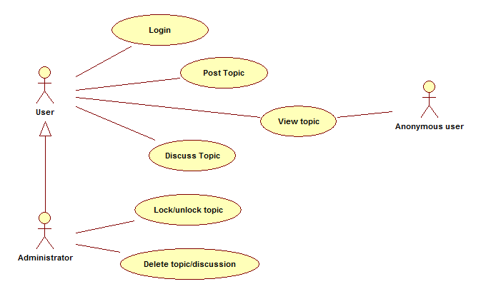

## Activity Diagram

### Login

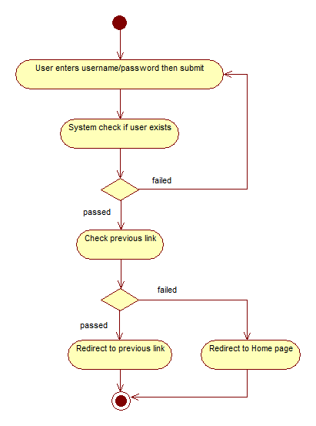

### View topic

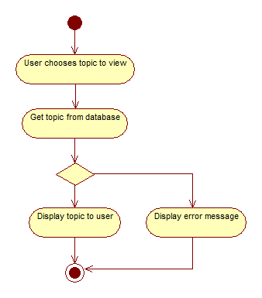

### Post topic

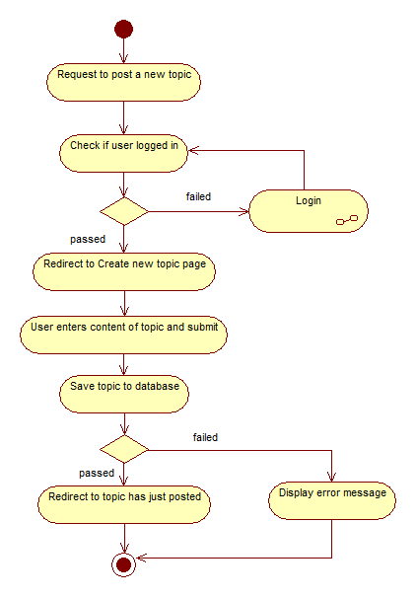

### Discuss topic

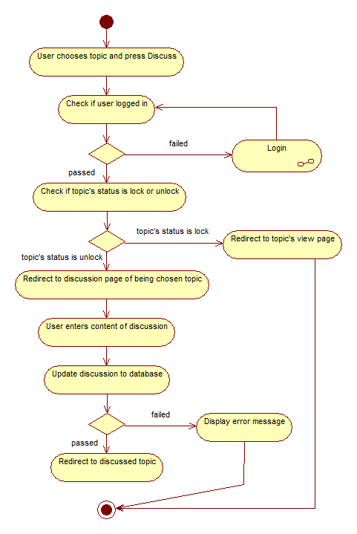

### Lock/unlock/delete topic

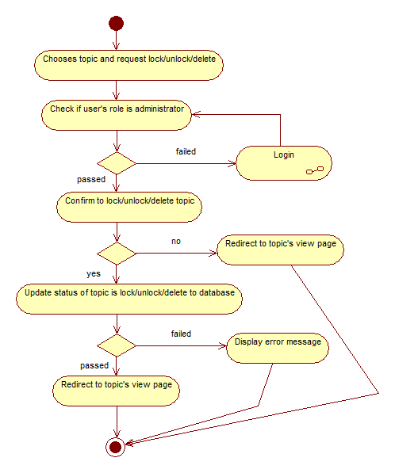

## Sequence Diagram

### Login

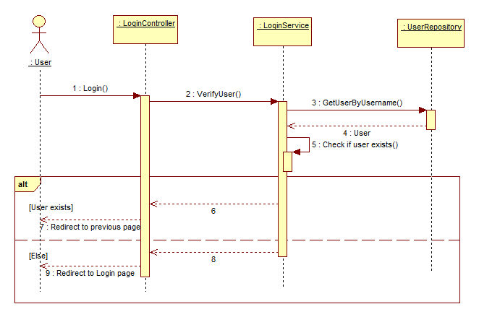

### View Topic

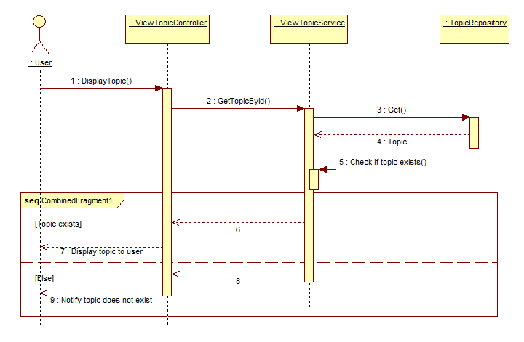

### Post topic

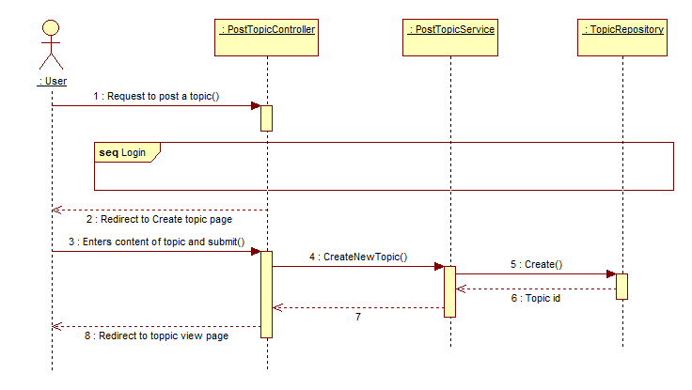

### Discuss Topic

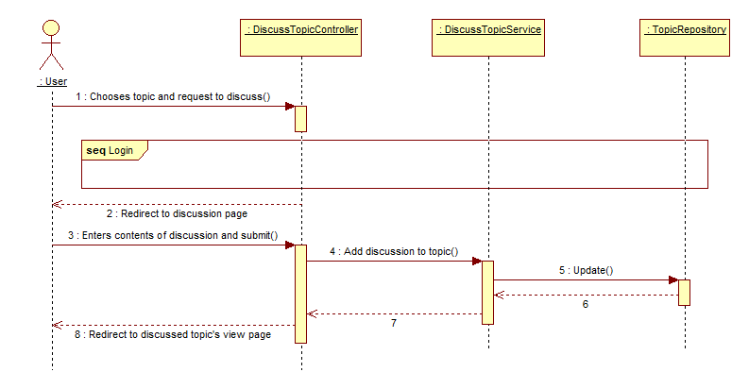

### Lock/unlock/delete topic

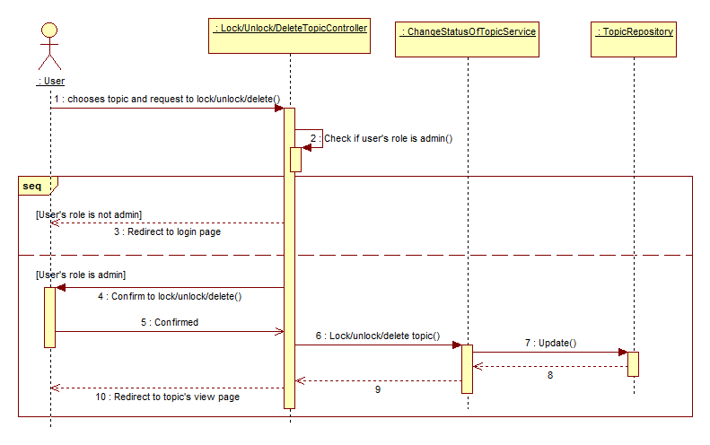

## Screens Design

### Screen XYZ

[Description the purpose of the screen as to ensure the client and developer agrees on its functionality.]

[include screen shot here]

**Security Group**: [List the security groups that may use the screen]

[Describe each field on the screen and how it is derived]

|  |  |  |
| --- | --- | --- |
| No | Data | Data Description |
| 01 | Data XYZ |  |
|  |  |  |

[Describe each action that can be performed from this screen. This usually involves command buttons, menu items, etc.]

|  |  |  |
| --- | --- | --- |
| No | Actions | Action Description |
| 01 | Action XYZ |  |
|  |  |  |

## Class Diagram

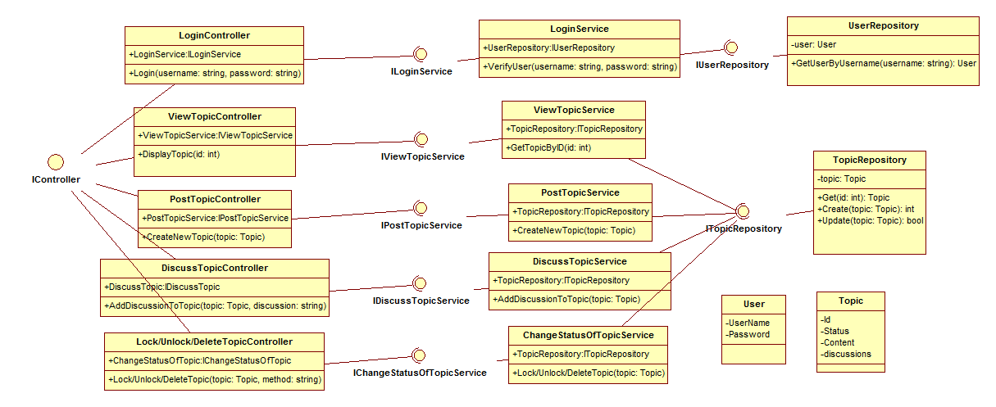

View detailed image in attachment file named ClassDiagram.jpg

## Class Specification (s)

### Classes Summary

To be defined

### Class Details

To be defined

#### **ClassPostController**

#### **Attributes**

|  |  |  |  |  |  |
| --- | --- | --- | --- | --- | --- |
| No | Attribute | Type | Default | Note | Description |
| 01 |  |  |  |  |  |
|  |  |  |  |  |  |
|  |  |  |  |  |  |

#### **Methods**

|  |  |  |
| --- | --- | --- |
| No | Method | Description |
| 01 |  |  |
| 02 |  |  |
|  |  |  |

#### **[XXX] Method**

|  |  |
| --- | --- |
| **Declaration** | |
| **Method Declaration** |  |
| **Description** |  |
| **Overrides** | |
| Not Applicable. | |
| **Parameter** | |
| **Name** | **Type** |
|  |  |
|  |  |
|  |  |
| **Return Type** | |
|  | |
| **Throws** | |
|  | |

##### Implementation

[How to implement the method, it can be in pseudo code or activity diagram or just words]

#### **Class PostService**

#### **Attributes**

|  |  |  |  |  |  |
| --- | --- | --- | --- | --- | --- |
| No | Attribute | Type | Default | Note | Description |
| 01 |  |  |  |  |  |
|  |  |  |  |  |  |
|  |  |  |  |  |  |

#### **Methods**

|  |  |  |
| --- | --- | --- |
| No | Method | Description |
| 02 |  |  |
|  |  |  |
|  |  |  |

#### **Class PostRepository**

#### **Attributes**

|  |  |  |  |  |  |
| --- | --- | --- | --- | --- | --- |
| No | Attribute | Type | Default | Note | Description |
|  |  |  |  |  |  |
|  |  |  |  |  |  |
|  |  |  |  |  |  |

#### **Methods**

|  |  |  |
| --- | --- | --- |
| No | Method | Description |
| 02 |  |  |
|  |  |  |
|  |  |  |